COSC 641
Spring 2020
FSU

Bank of Frostburg State University

Database Final Project
COSC 641 Part 1a

You may use your tables from your last semester COSC 640 project or use the data from
PROJECT2020.table_name. You can copy each table into your Oracle account like:

CREATE TABLE car
AS
SELECT *
FROM PROJECT2020.car;

Check your data:
SELECT *
FROM car;

Check the attributes:
DESC car;

Note 1: It is common to make changes to the base tables (add or delete fields). You can use ALTER TABLE. To add/delete fields to your tables. The added fields will have value of NULL for now.
Note 2: All of he data must be in your based tables. We will not create FORCED view.
Note 3: For complex queries you can create intermediate views and create view from view.
Note 4: We will use the views and sequences later on in the project. For now just create them.

Please try to keep the names as close to the original names as you can. If there is any missing data, feel free to add it to your tables.

List of tables are:
- BRANCH
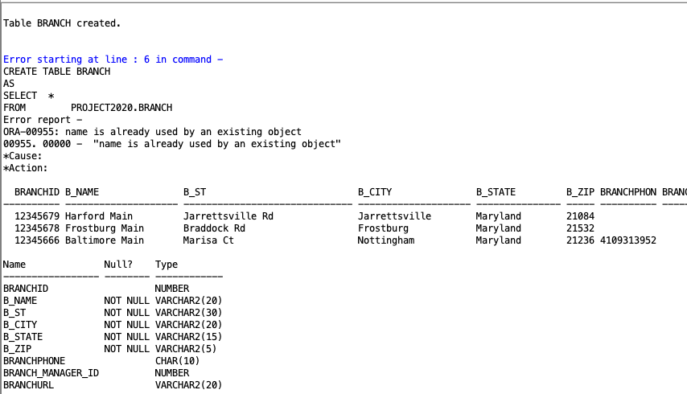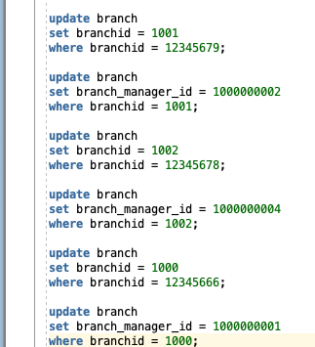
- I made the above updates arbitrarily as the branchids and manager_ids did not match anything else in the system.
- DEPARTMENT
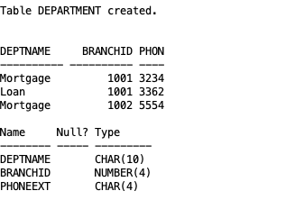
- CAR
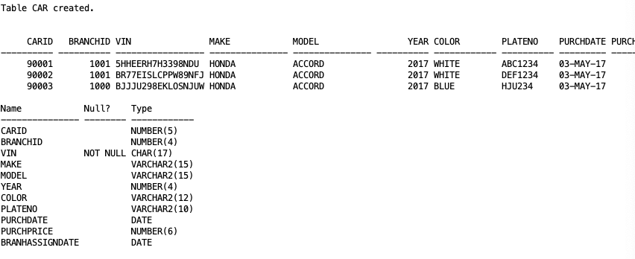
- DRIVER
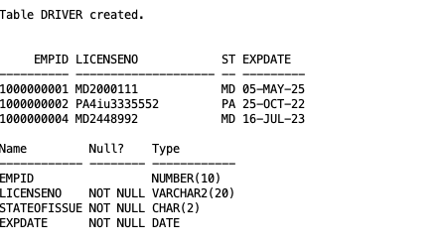
- CUSTOMER
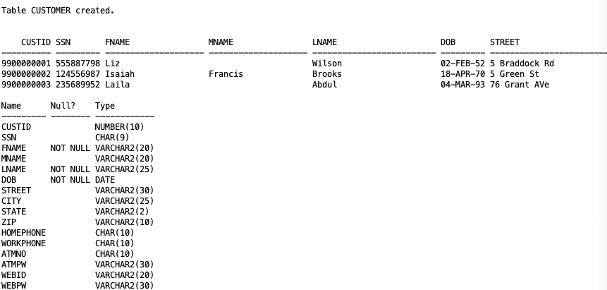
- BANK_EMPLOYEE
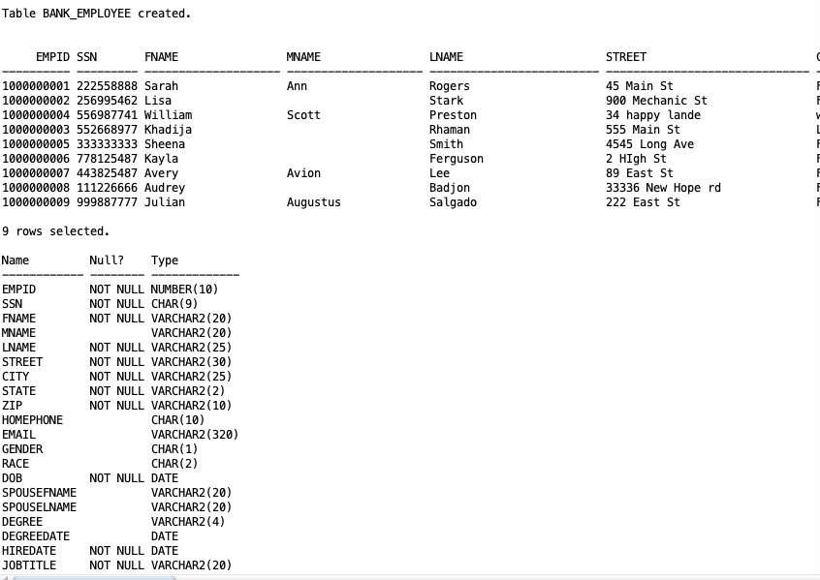
- JOB
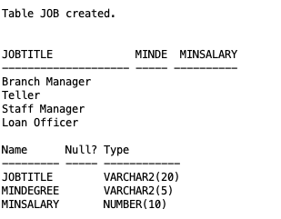
- EMP_ANNUAL_DATA
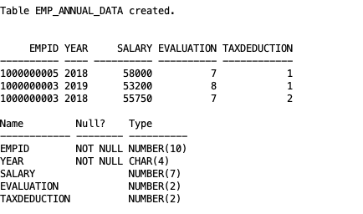
- BRANCH_EMPLOYEE
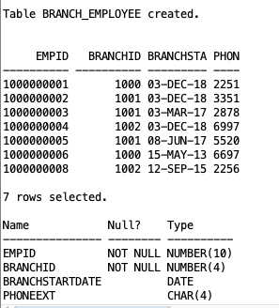
- ATM
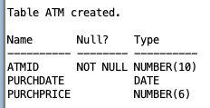
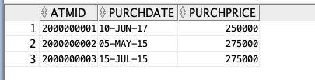
- BRANCH_ACCESS_POINTS
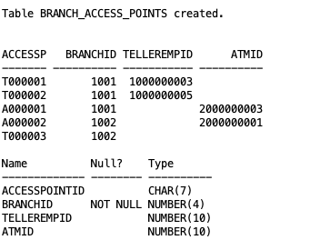
- BRANCH_MANAGER
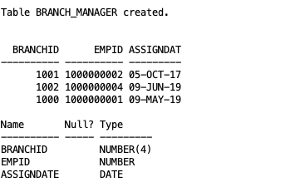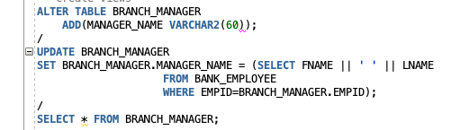
- LOAN
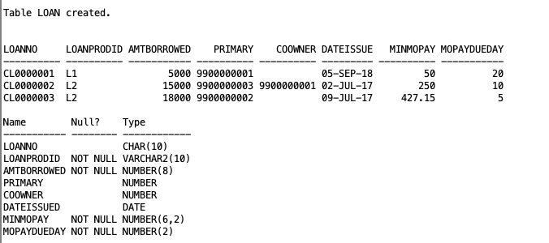
- LOAN_PRODUCT – AFTER THIS WASN’T FOUND, I SEARCHED ALL_TABLES AND FOUND LOAN_PRODUCT WHICH I USED 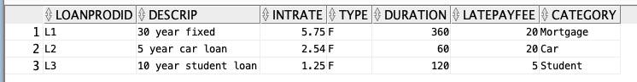 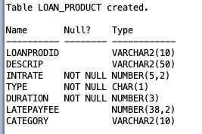
- DEPOSIT_ACCT – ORIGINALLY MISSING ‘T’ IN INSTRUCTIONS, ADDED AFTER SEARCHING ALL_TABLES 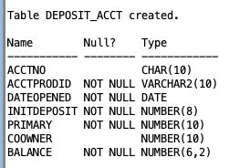
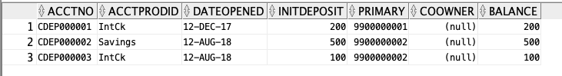
- DEPOSIT_ACCT_PRODUCT- ORIGINALLY MISSING ‘T’ IN INSTRUCTIONS, ADDED AFTER SEARCHING ALL_TABLES 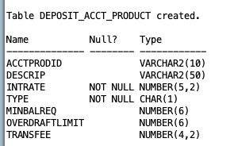 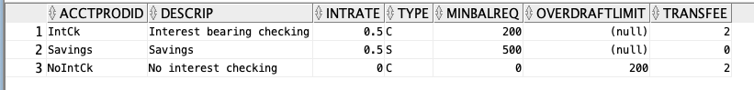

- CD_ACCOUNT 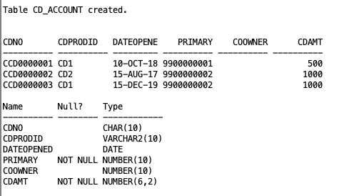
- CD_PRODUCT 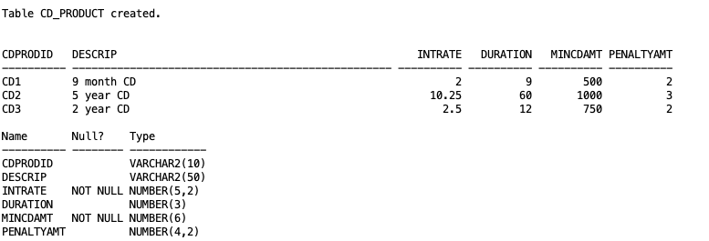
- CREDIT_ACCOUNT 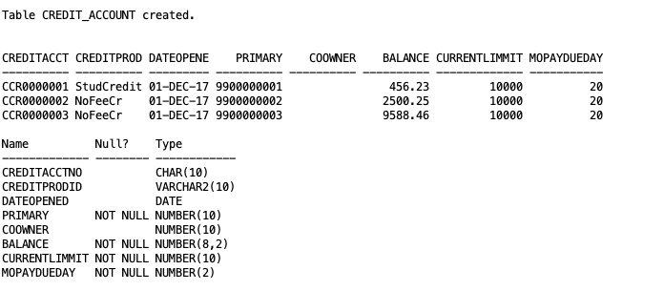
- CREDIT_PRODUCT 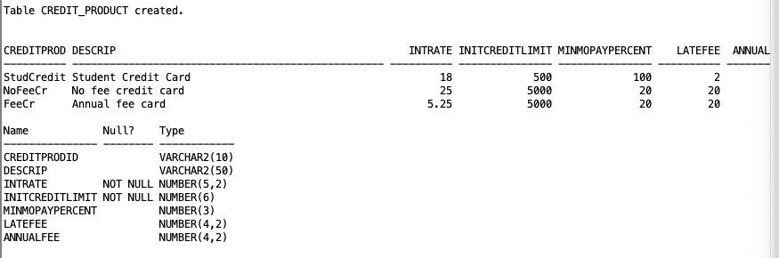
- LOAN_PAYMENT 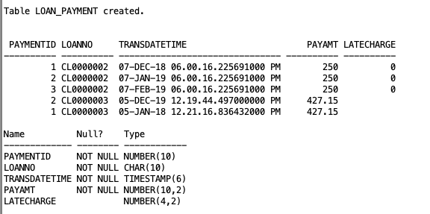
- DEPOSIT_ACCT_TRANSACTION 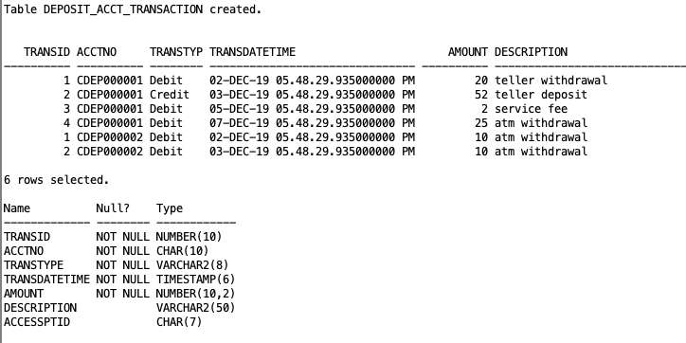
- CREDIT_ACCT_TRASACTION 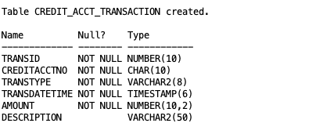
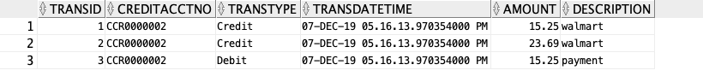
Chapter 7-Create the following views:
- Employee_info with the following attributes:

Name of Employee
Address
Zip code of Employee Address
SSN
Title
Current Yearly Salary
Current Tax Deduction Rate
The date s/he was employed
Birth Date
Age of Employee
Employee Branch Phone Extension s/he Works at
Branch Phone Number
Branch Name (Employee Works at)
Highest Degree
Highest Degree date
Name of the Employee Manager (Branch)
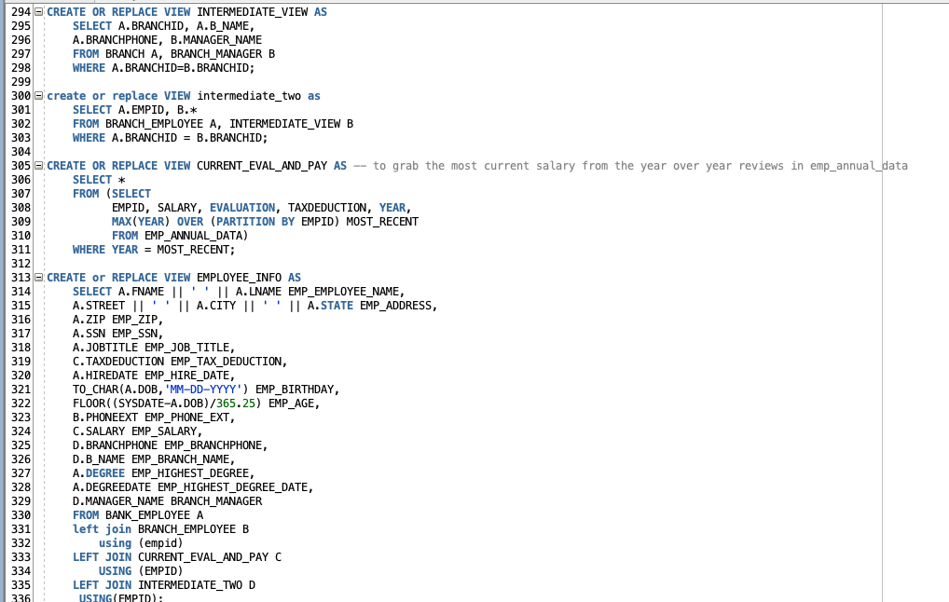
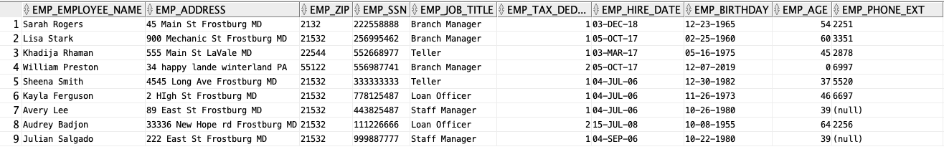
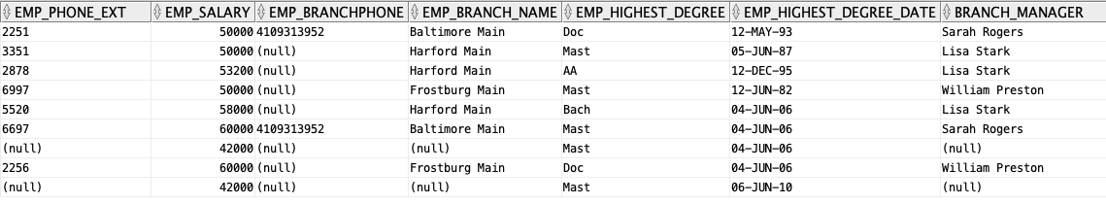

b. Employee_salary with the following attributes:

Name
Address
SSN
Salary
Tax Deduction Rate
Birth Date
Branch Employee Works at
Total Cost of Employee Salaries at the branch s/he works
Highest salary at his/her branch
Average salary at his/her branch
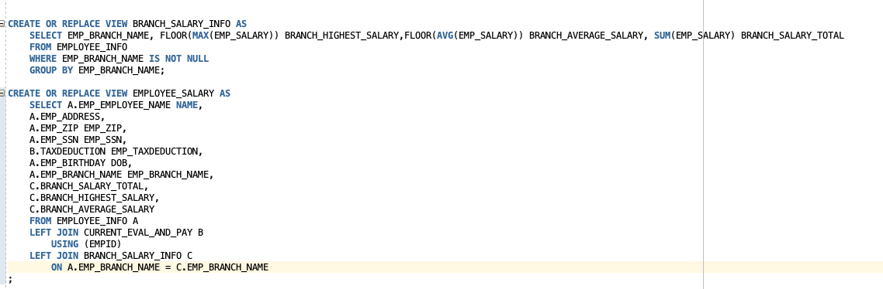
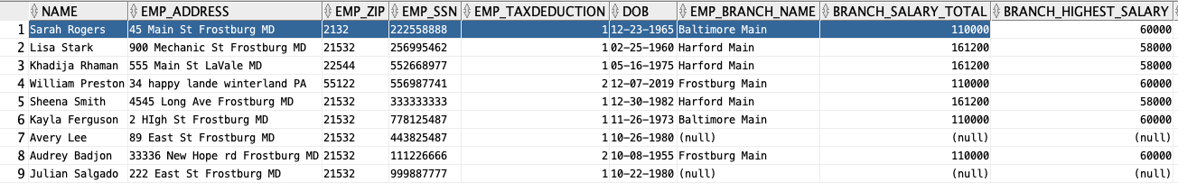
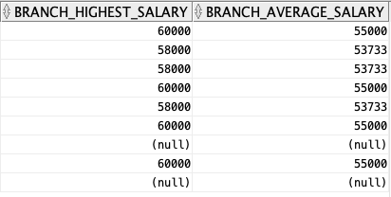
c. Branch_info with the following attributes:

Branch ID
Name
Address
Phone Number
Fax Number ← to be inputted later
Number of Employee at this Branch
Regular Open Hours
Days Of Week Business is open
Category
Manager Name
Total Transactions Done at this Branch
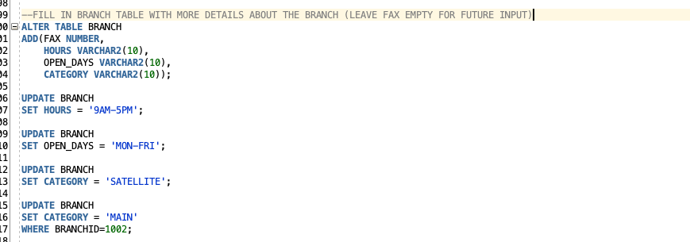

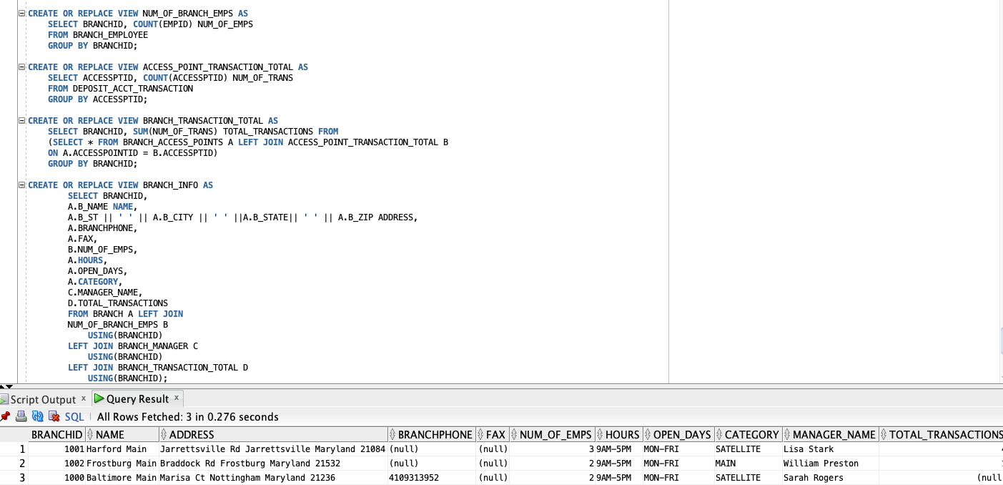
d. Valued_Customers with the following attributes:
Describe how you select the important customers in this bank.
SSN
Name
Age
Home Phone
Work Phone
Address
Zip Code
Email ← to be inputted later
State they live in
Total number of tractions the customer has done in 2015
Total amount ($) of tractions the customer has done in 2015
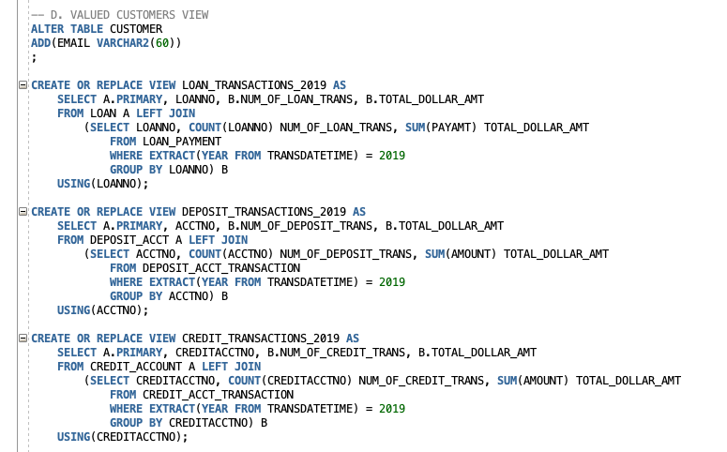
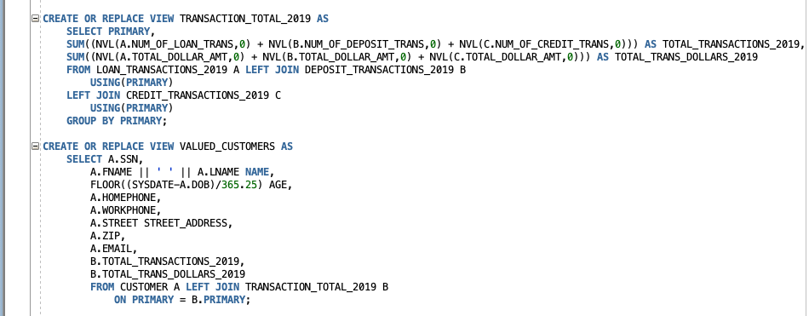

e. Statistics_by_Branch with the following attributes (Read only view):

Branch Id
Branch name
Year
Total deposit in that year for this location
Total number of transactions
Total number of employee at this branch
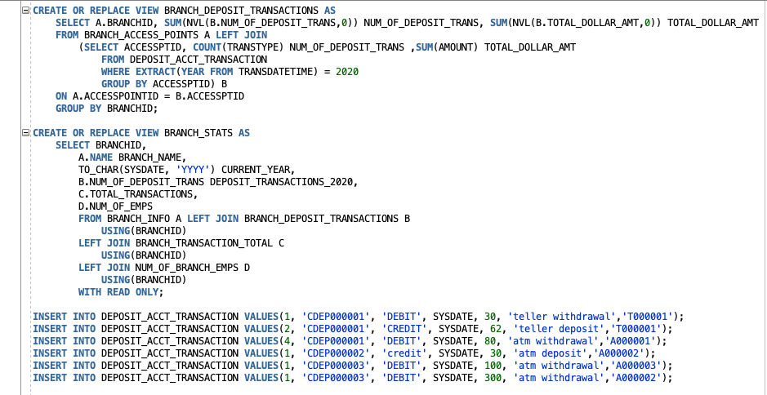
--------I added some transactions for this year so that there would be some data to query for the Deposit_transactions_2020 field.

-Create two more views that can be used by customers. (Make sure it is useful to the customers. You will be graded based on the usefulness of the view) 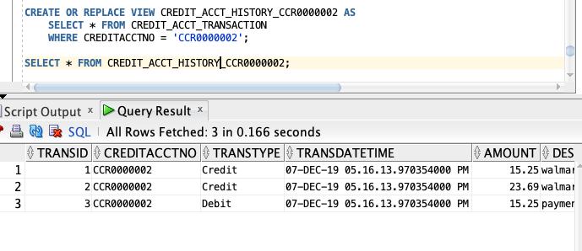
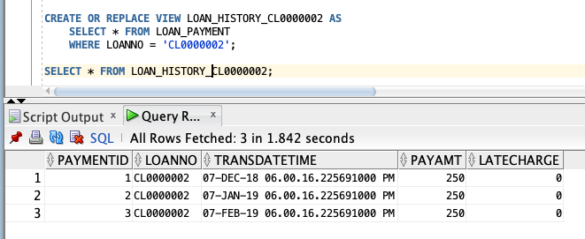

-Create two more views that can be used by management. (Make sure it is useful for managerial decisions)

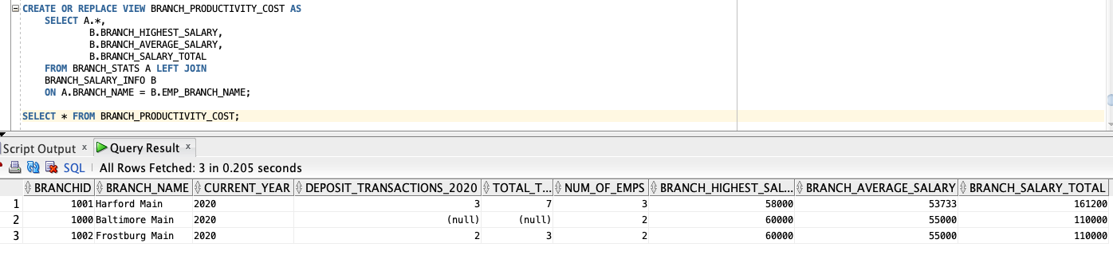
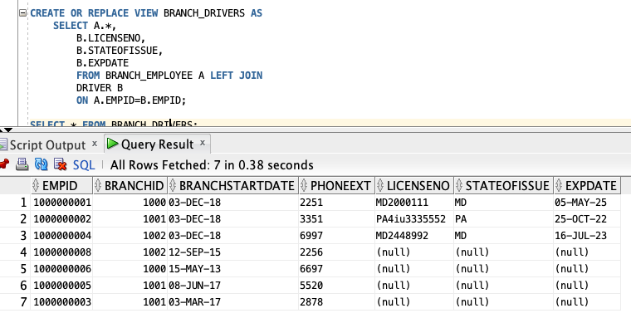

Chapter 9
a- Create a sequence called ID_generator to be used for Account ID.
Start with 1001
Generate only odd numbers for security
Cache 50 numbers at a time
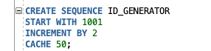

b- Create a sequence to be used for the Transaction ID. (Make your own assumption).

